**SB Horticulture PSD to HTML5 / SCSS**

Project Scope 1

Home Page 2

1.1. Home Page Slider 1, Services & Partner Hover Logo 2

1.2. Home Page Slider 2, Services & Partner Hover Logo 3

1.3. Home Page Slider 3, Services & Partner Hover Logo 4

1.4. Home Page Slider 4, Partner Hover Logo 4

1.5. Home Page Slider 5, Partner Hover Logo 5

1.6. Home Page Slider 6, Partner Hover Logo 5

1.7. Home Page Enquire Modal Popup 6

1.8. Home Page Sticky Nav Menu 6

1.9. Tablet Nav & Footer 7

1.10. Mobile Nav & Footer 7

Contractor Form 9

# Project Scope

This is a PSD to HTML5 CSS3/SCSS job that requires to be pixel perfect with a consistent look and feel across the design which includes all gutters, margins and padding in all responsive views. Please use your own initiative with the mobile and tablet views apart from the header and footer which has be drawn out for you. In the responsive views the text and images should all be visible on the mobile and tablet with enough guttering, margin and padding.

**Standards**

Work carried out needs to be adhere to a semantic HTML5 structure using: <header><nav><main><article><section><aside><footer> tags.

**Framework**

You will use the Foundation Zurb 6 framework

**2 pages need to be coded in HTML5 / SCSS using the Foundation Zurb 6 – Zurb Stack**

1. Home Page
2. Style Guide

On the home page the large image at the top is a image slider with 6 images with different text on each slide. Then under that the three services will turn green when a user hovers over it, which is a link which will go to the service Pages. The logos above the footer will have a hover effect too. The sticky navigation is on the style guide page. So when a user scrolls down it will look like the number 3 nav on the style guide. When a user clicks on Enquire in the nav menu it will display a pop up modal like the one in the style guide. Please see below for further instructions.

The home page navigation is different to the sub page “style guide”. Both navigation menus need to be sticky to look like the menu number 3 in the style guide.

Please use HTML5 semantic tags <nav>, <main>, <article>, <section>, <aside>, <header>, <footer> for structure and don’t litter the pages with <div> tags. Please don’t use inline styles. Just SCSS with the foundation Zurb Stack Template.

# Home Page

## Home Page Slider 1, Services & Partner Hover Logo

1st Services hover

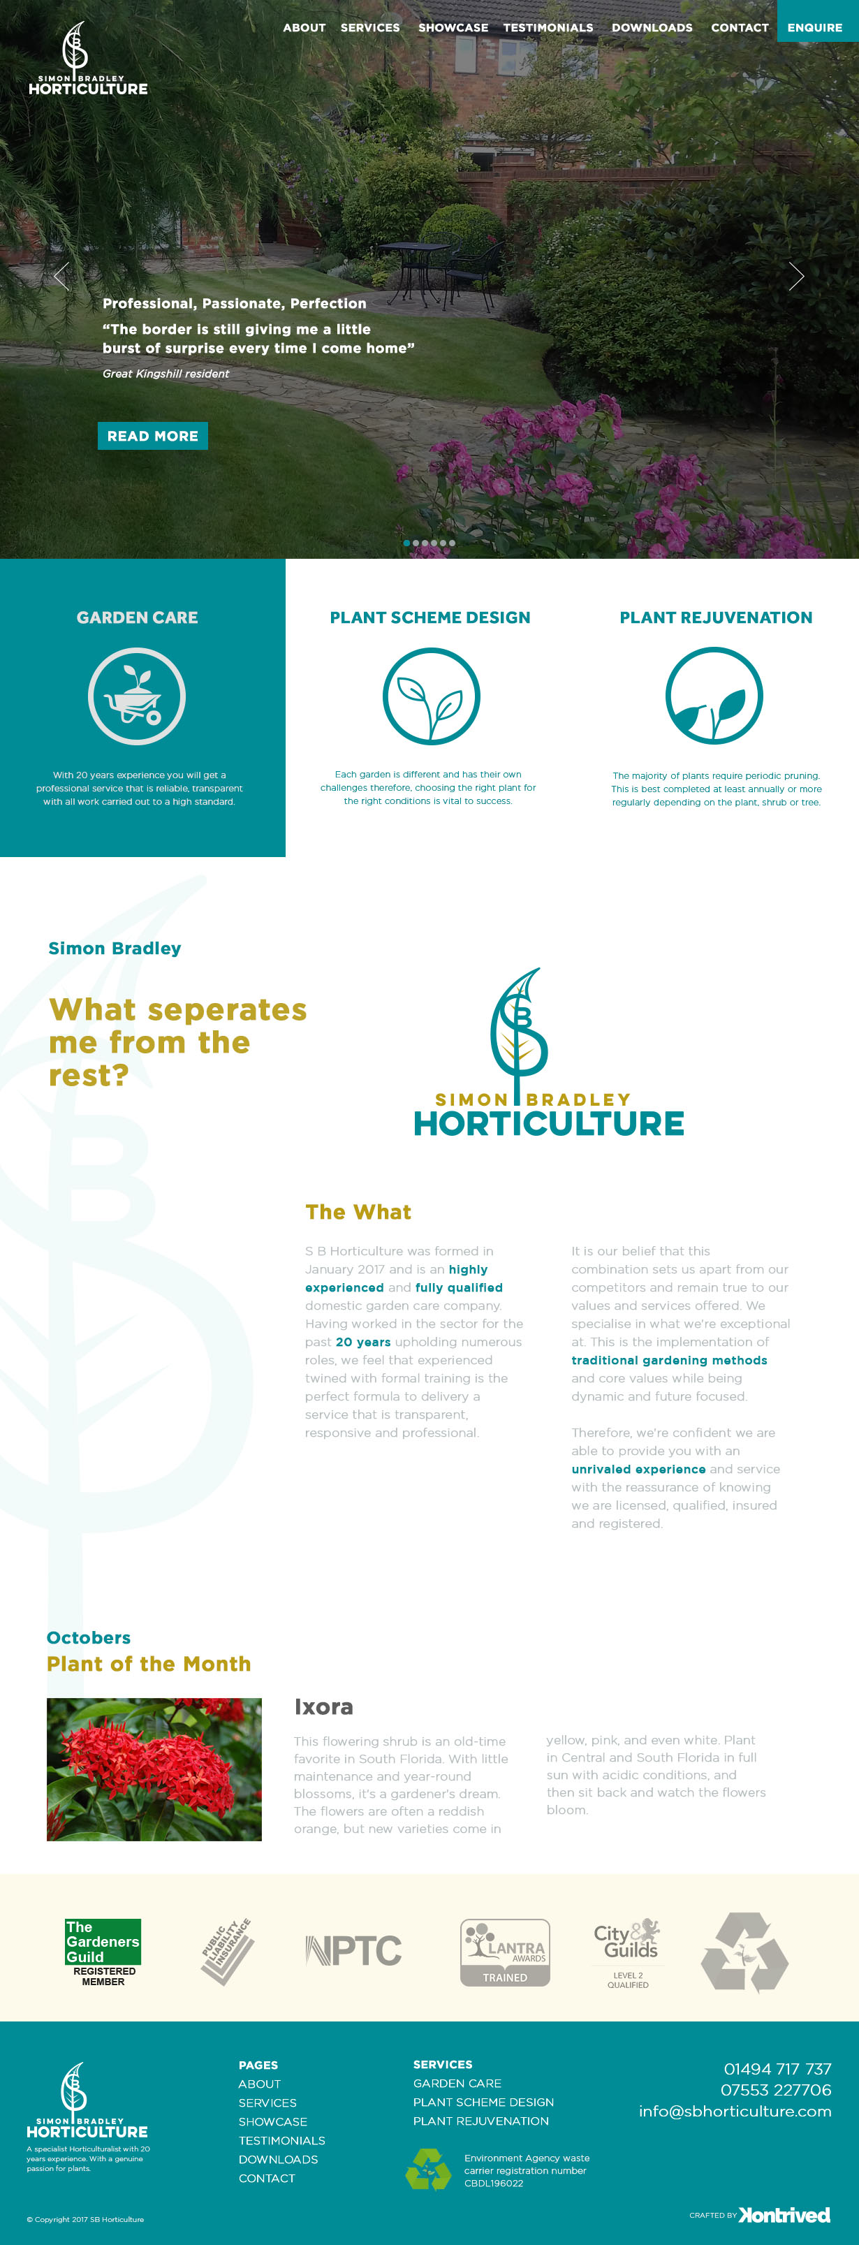

1st Partner logos hover



## Home Page Slider 2, Services & Partner Hover Logo

2nd Services hover

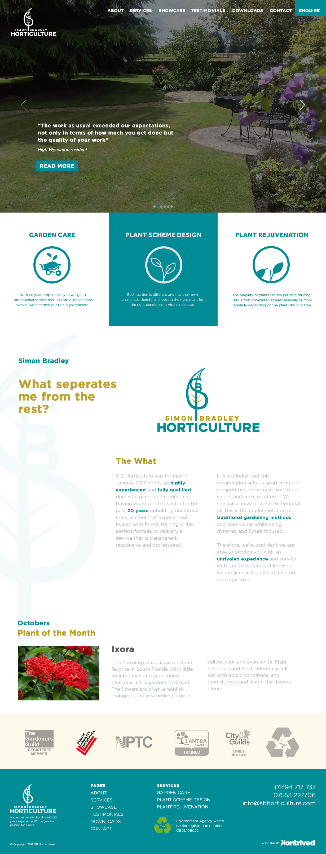

2nd Partner logos hover



## Home Page Slider 3, Services & Partner Hover Logo

3rd Services hover

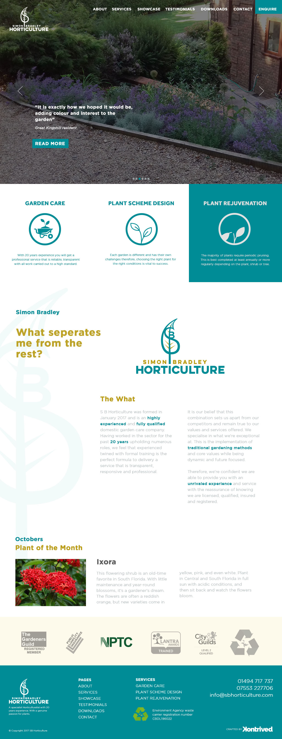

3rd Partner logos hover



## Home Page Slider 4, Partner Hover Logo

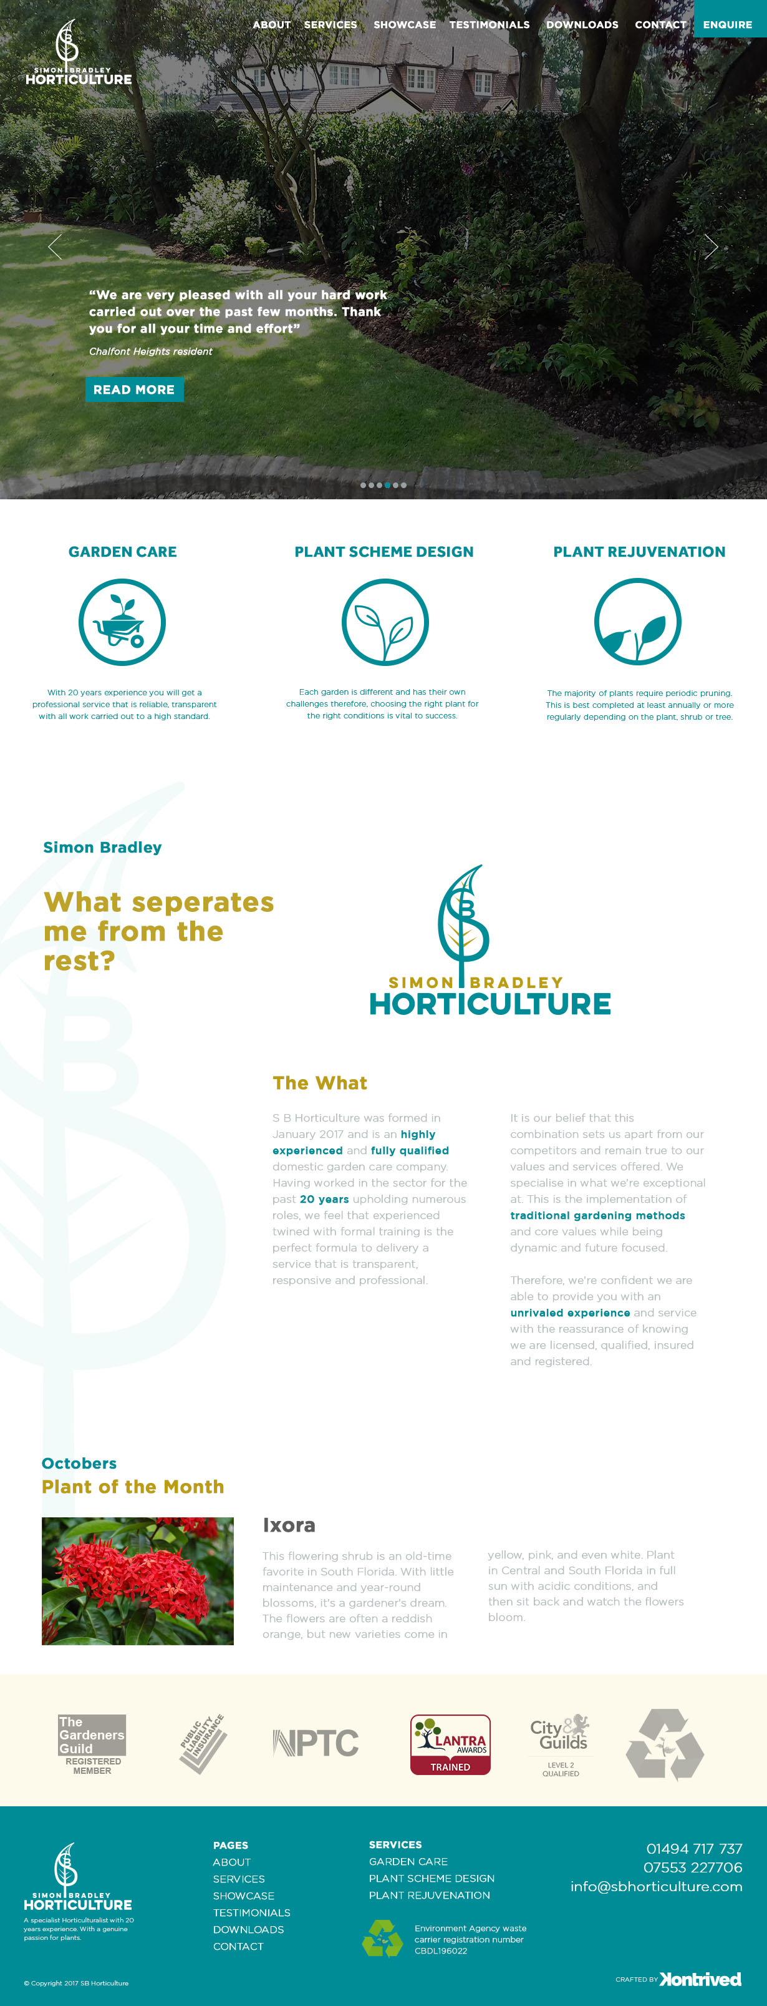

4th Partner logos hover



## Home Page Slider 5, Partner Hover Logo

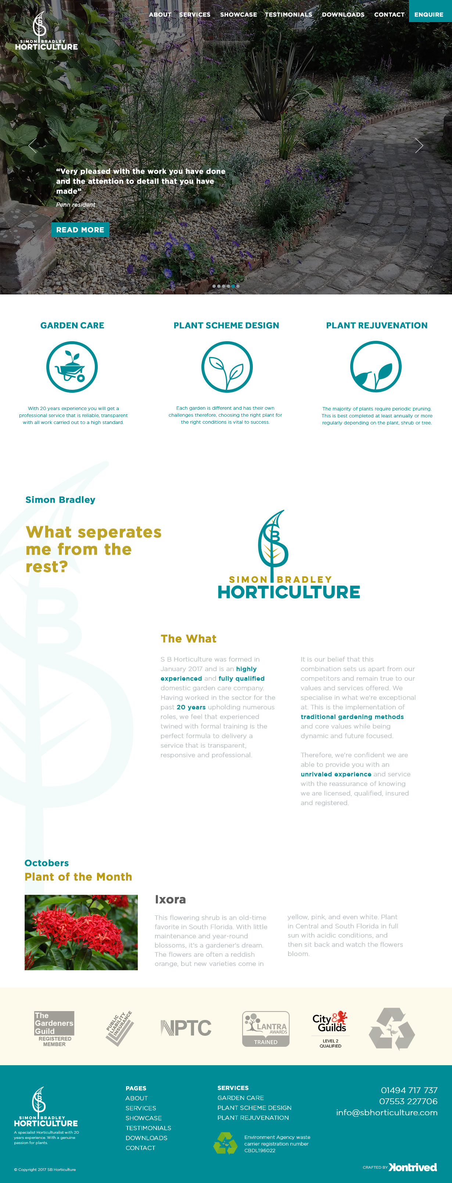

5th Partner logos hover



## Home Page Slider 6, Partner Hover Logo

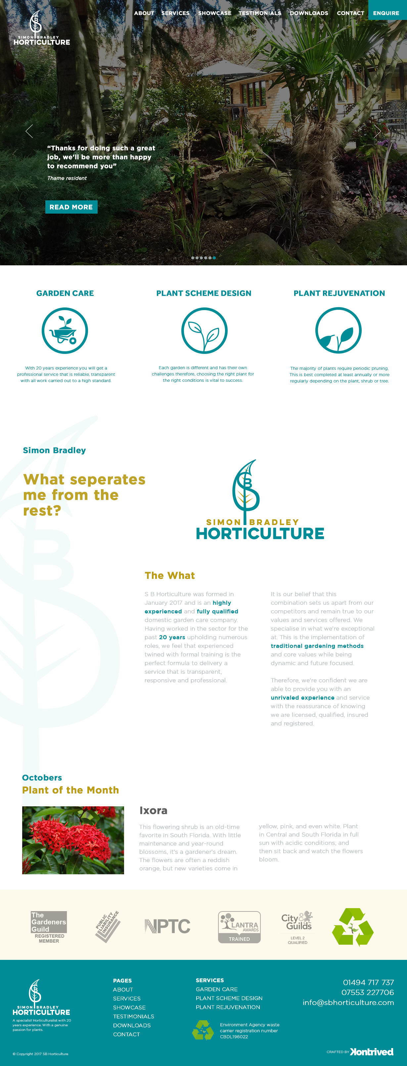

6th Partner logos hover



## Home Page Enquire Modal Popup

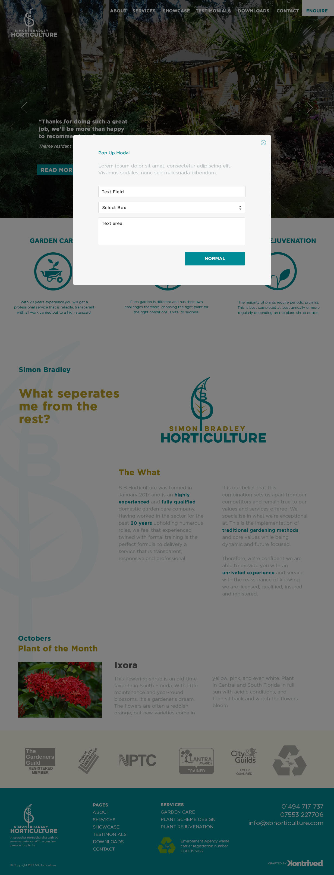

## Home Page Sticky Nav Menu

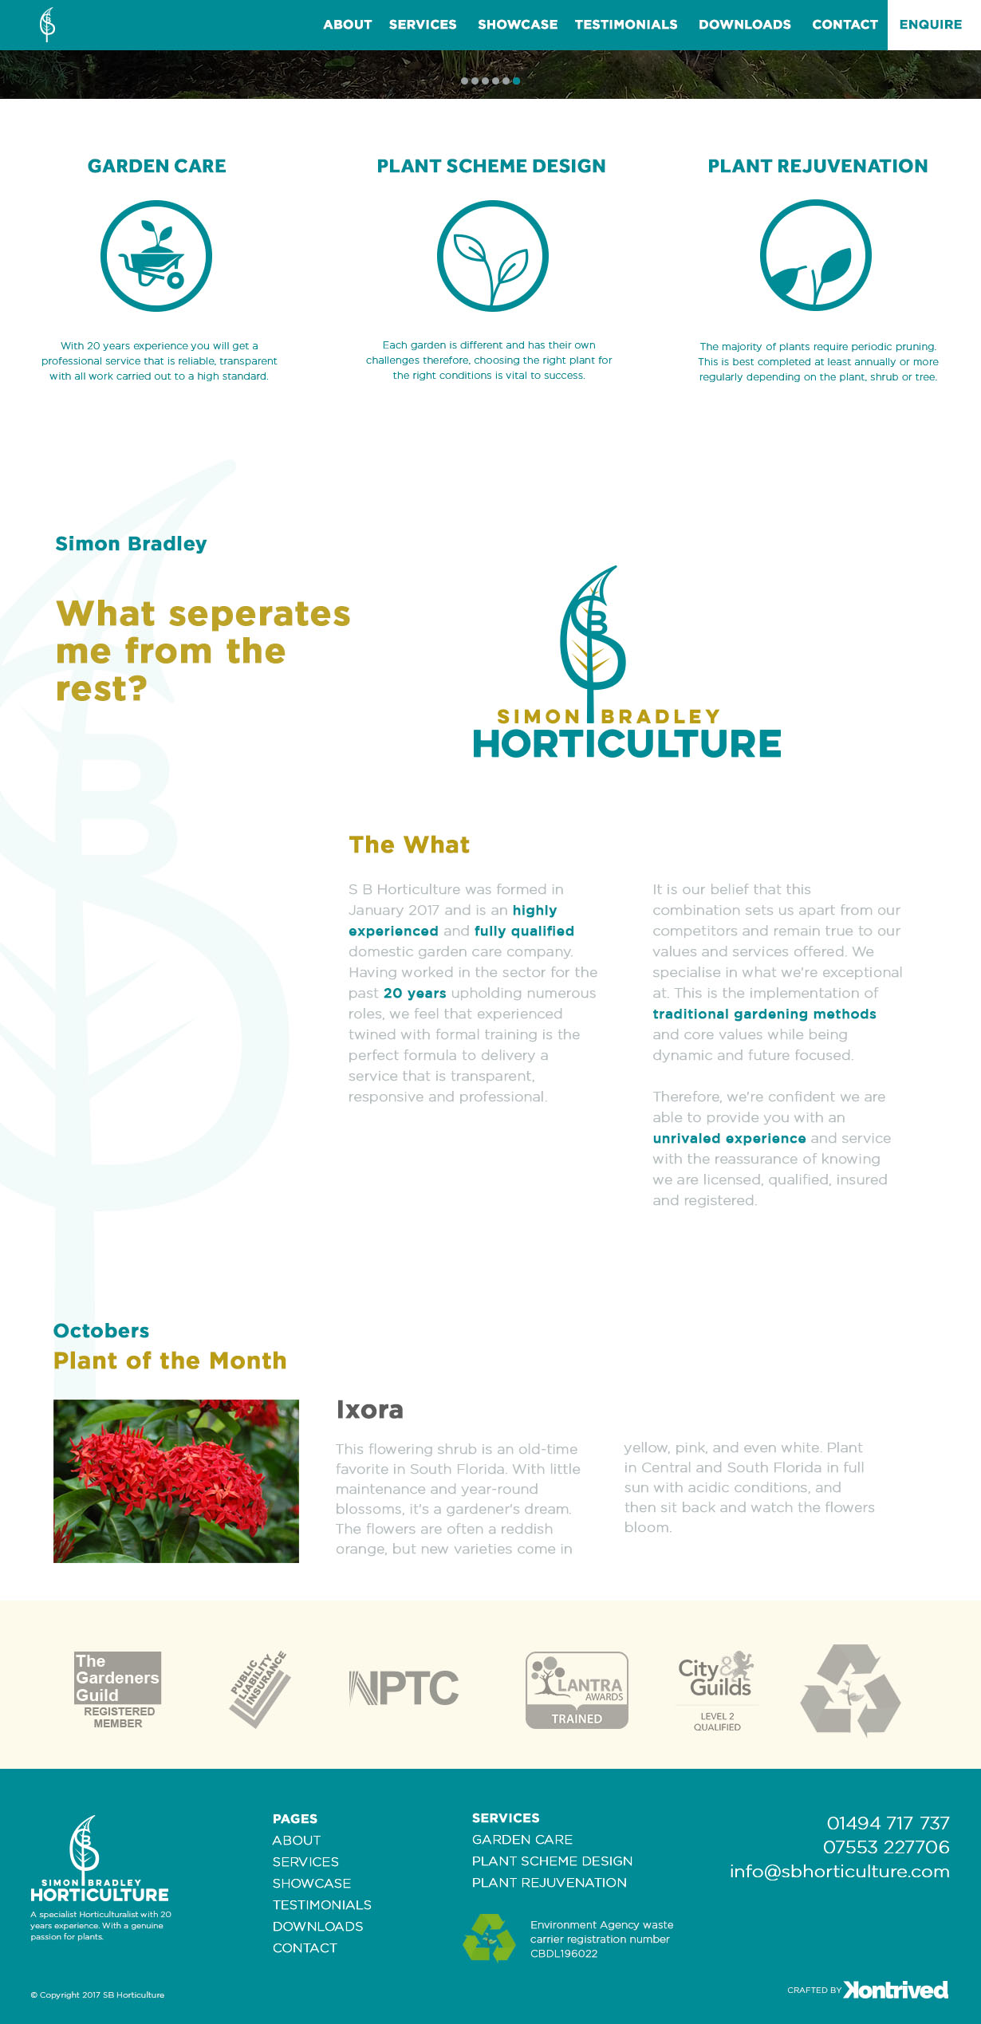

## Tablet Nav & Footer

This should look presentable if you are struggling to make this look right I will design the look for you.

## Mobile Nav & Footer

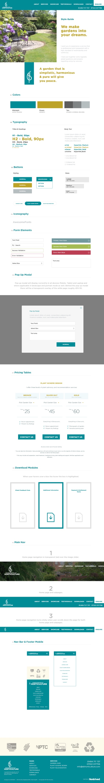

Style Guide

The style guide also needs coding, which also needs to be responsive to mobile & tablet and laptop.

You don’t have to code the following in this page as they are in the home page:

1. Modal Pop up

